Portfolio Project: Concurrency Concepts
Boubacar Barry
Colorado State University Global
CSC450-1: Programming III
Russell Frith
20240505

Source Code
public class CounterApplication {
public static void main(String[] args) {
Thread countUpThread = new Thread(() -> {
for (int i = 1; i <= 20; i++) {
System.out.println("Count Up: " + i);
try {
Thread.sleep(100); // Simulate some work
} catch (InterruptedException e) {
Thread.currentThread().interrupt();
}
}
});

Thread countDownThread = new Thread(() -> {
for (int i = 20; i > 0; i--) {
System.out.println("Count Down: " + i);
try {
Thread.sleep(100); // Simulate some work
} catch (InterruptedException e) {
Thread.currentThread().interrupt();
}
}
});

countUpThread.start();
try {
countUpThread.join(); // Wait for countUpThread to finish
} catch (InterruptedException e) {
e.printStackTrace();
}

countDownThread.start();
}
}

Pseudo Code
1. Start
2. Create and start a thread named countUpThread
2.1. In countUpThread, loop from 1 to 20
2.1.1. Print "Count Up: [current_number]"
2.1.2. Pause the thread for a short period (simulate work)
2.2. Handle any interruptions
3. Wait for countUpThread to complete its execution
4. Create and start a thread named countDownThread
4.1. In countDownThread, loop from 20 down to 1
4.1.1. Print "Count Down: [current_number]"
4.1.2. Pause the thread for a short period (simulate work)
4.2. Handle any interruptions
5. End

Analysis
Performance Issues with Concurrency:
Context Switching: Frequently switching between threads can introduce overhead, especially if the threads are not doing significant work and are simply counting. This can lead to reduced performance as the CPU spends time switching contexts rather than executing the thread's code.
Synchronization Overhead: Although not directly applied in this simple example, in more complex scenarios, synchronizing shared resources (if any) between threads can cause delays and reduce performance due to the need for locking mechanisms.

Vulnerabilities Exhibited with Use of Strings:
In this simple counter application, strings are used statically ("Count Up: ", "Count Down: ") and not manipulated in a way that introduces vulnerabilities. However, in applications where strings come from external sources or user input, risks such as SQL injection or script injection in web applications could arise. Ensuring strings are properly sanitized and validated becomes crucial.

Security of the Data Types Exhibited:
The primary data types used are integers for counting and threads for concurrency. Integers are safe for the counting operation we're performing here, but care should be taken in applications where integer overflow or underflow might be a concern.
Using threads directly is generally safe in this context, but developers should be cautious of thread interference and memory consistency errors in applications with shared data. Utilizing high-level concurrency utilities from the java.util.concurrent package can help manage these risks more effectively.

In summary, while the CounterApplication demonstrates basic concurrency concepts in Java through the creation and management of threads, it also touches on broader considerations for building robust and secure concurrent applications. Being mindful of performance implications, secure handling of strings, and the safety of data types used in a concurrent context ensures the development of efficient, secure applications.

Screenshot of Application Executing

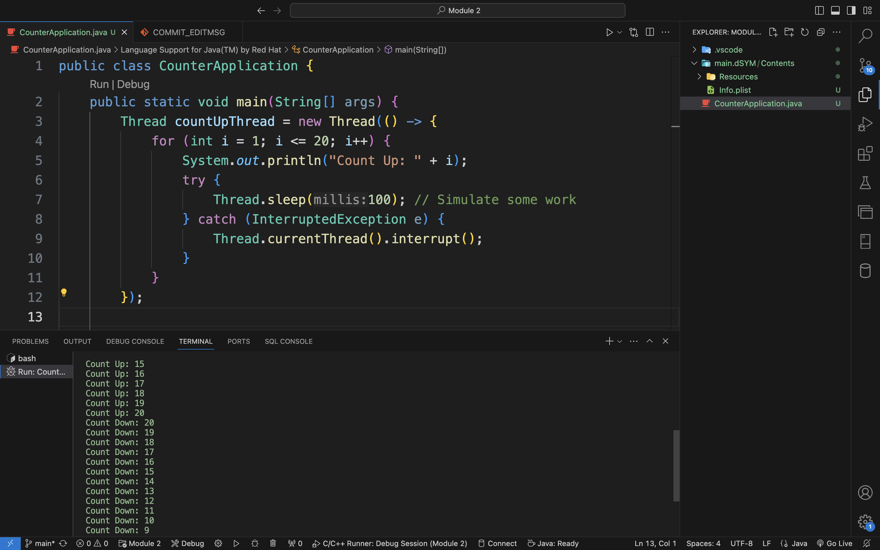
C++ and Java versions Comparison

In the realm of software development, particularly concerning multi threaded applications, the nuanced differences in performance and security between Java and C++ become evident. Each language offers a unique approach to concurrency, threading, and security, influenced by their underlying design philosophies, runtime environments, and standard libraries. By examining a counter application implemented in both Java and C++, we can glean insights into these differences, their implications on performance and security, and ultimately, which implementation may be less vulnerable to threats.

Performance Analysis
Java
Java's concurrency model is built atop the Java Virtual Machine (JVM), providing a layer of abstraction that ensures thread safety and simplifies the development of multi-threaded applications. The Thread class, alongside constructs like synchronized blocks and higher level concurrency utilities in the java.util.concurrent package, facilitates the creation and management of threads. In the provided Java counter application, threads are instantiated and managed directly through the Thread class, with thread safety achieved via the JVM's intrinsic locking mechanism during the sleep interruption handling.
This abstraction, while beneficial for cross-platform consistency and ease of use, introduces a performance overhead. The JVM must translate thread operations to the underlying operating system's native threading model, a process that can potentially lead to increased latency. Furthermore, the JVM's garbage collection process, though vastly improved over the years, can introduce unpredictable pauses, affecting the real-time performance of applications.

C++
Conversely, C++ offers a more granular level of control over threading and synchronization mechanisms, courtesy of the Standard Template Library's (STL) <thread>, <mutex>, and other concurrency headers introduced in C++11. This control fosters an environment where performance can be finely tuned, as demonstrated in the C++ implementation of the counter application. The use of std::mutex for output synchronization, directly interacting with the operating system's threading API, allows for potentially lower overhead compared to Java's JVM managed threads.
However, this finer control comes at the cost of complexity and a higher potential for developer error, such as deadlocks or race conditions, if not meticulously managed. The explicit lock and unlock operations on std::mutex necessitate a disciplined approach to resource management and synchronization, pivotal for maintaining application performance and integrity.

Security Considerations
The security implications of Java and C++ applications diverge significantly, primarily due to their memory management models and type safety features. Java, with its managed runtime environment, provides a safeguard against a range of memory-related vulnerabilities, such as buffer overflows and dangling pointers—common pitfalls in C++ development. The automatic memory management and garbage collection in Java eliminate a class of security vulnerabilities intrinsic to manual memory management in C++.

C++, while powerful and flexible, requires developers to manually manage memory allocation and deallocation. This manual management, albeit offering more control over application resources, introduces the risk of memory leaks, buffer overflows, and undefined behavior if mishandled. The counter application in C++, though simple, hints at the meticulous attention required to ensure thread safety and memory security, especially in more complex applications involving dynamic memory allocation and multiple synchronization primitives.

Conclusion
In comparing the Java and C++ implementations of a basic counter application, it becomes apparent that each language's approach to concurrency, performance, and security is deeply influenced by its core design principles. Java's managed environment and abstracted concurrency model offer ease of use and inherent security at the potential expense of performance overhead and less control. In contrast, C++ provides granular control over threading and memory, conducive to higher performance but requiring rigorous management to mitigate security vulnerabilities.

Given these considerations, the Java implementation may be considered less vulnerable to security threats due to its managed runtime environment, automatic memory management, and type safety features, reducing the risk of a wide array of common vulnerabilities found in lower-level languages like C++. However, the choice between Java and C++ for a particular application ultimately hinges on the specific requirements for performance, control, cross-platform compatibility, and the development team's expertise.

Performance Implications of Concurrency Models
The concurrency model adopted by a programming language fundamentally influences its performance characteristics, especially in the context of multi-threaded applications. Java and C++, each with its unique approach to concurrency, exhibit distinct performance profiles in applications like the counter examples provided.

Context Switching and Synchronization Costs
In Java, the abstraction provided by the JVM simplifies thread management but at a cost. The JVM's thread scheduling and garbage collection introduce latency not present in more directly managed environments like C++. The C++ standard library, on the other hand, offers primitives for fine-grained control over thread execution and synchronization. However, the direct control in C++ over thread management demands a deeper understanding of the operating system's concurrency model, potentially leading to more efficient but complex code.
The explicit use of std::mutex in the C++ counter application to synchronize console output is a testament to this control. While ensuring thread safety, it introduces the overhead of lock contention. Java abstracts these details away from the developer, trading off some performance for ease of use and safety.

Garbage Collection vs. Manual Memory Management
Java's garbage collector automates memory management, preventing memory leaks but introducing pause times that can affect application performance unpredictably. C++, with manual memory management, avoids such pauses but requires developers to diligently manage memory, freeing resources explicitly to prevent leaks. This difference is crucial in applications where performance predictability is essential.

Security Analysis
The security posture of an application is significantly influenced by the language's approach to memory management, error handling, and type safety.

Memory Safety
Java's strict memory management model and type safety offer robust protection against a range of memory-related vulnerabilities. The managed runtime environment automatically checks array bounds and ensures type correctness, mitigating common security risks such as buffer overflows and type confusion errors.
C++ offers more control but requires developers to manually ensure the safety of memory operations. The counter application in C++ does not directly manipulate memory in a manner that introduces vulnerabilities. However, the language's flexibility with pointers and manual memory management opens up potential avenues for security flaws in more complex applications.

Exception Handling
Both Java and C++ support structured exception handling mechanisms to manage errors gracefully. Proper exception handling is vital for maintaining application stability and preventing unwanted behavior that could lead to security vulnerabilities. The Java counter application demonstrates a basic try-catch mechanism to handle interrupted exceptions, a pattern that's crucial in larger, more complex Java applications for maintaining security and reliability.
C++, while offering similar mechanisms, places the onus on the developer to catch exceptions appropriately and ensure that resources are correctly managed even in error conditions. The RAII (Resource Acquisition Is Initialization) pattern in C++ aids in this but requires careful implementation to be effective.

Optimal Use Cases and Final Thoughts
Choosing between Java and C++ for a project often comes down to specific application requirements and the development team's expertise. For applications requiring high levels of security, such as web applications handling sensitive user data, Java's memory safety and managed environment offer advantages. C++, with its performance efficiency and lower-level system access, might be preferable for applications where control over hardware resources is critical, such as in embedded systems or high-performance computing applications.
Ultimately, both languages have their strengths and weaknesses in terms of performance and security. Java's counter application, with its simpler, abstracted concurrency model, may be less vulnerable to security threats thanks to its managed environment, making it a suitable choice for applications where security is a paramount concern. C++, while potentially offering higher performance, demands a rigorous approach to security, especially when dealing with manual memory management and direct system access.

In conclusion, the decision between Java and C++ should be informed by a detailed analysis of the application's requirements, considering both the performance characteristics and security implications of each language. Understanding the trade-offs involved in their concurrency models, memory management strategies, and security features is crucial for developing efficient, secure, and robust applications.

